DOCUMENTATION FOR CHARACTER CREATOR

Getting started:

* Import UMA from Unity store.
* Add UMADynamicCharacterAvatar to your scene.
* Add UMA_GLIB to your scene.
* Import CharacterCreatorSetupV2
* Drag and drop UMADynamicCharacterAvatar into the character creator script attached to the character creator module.

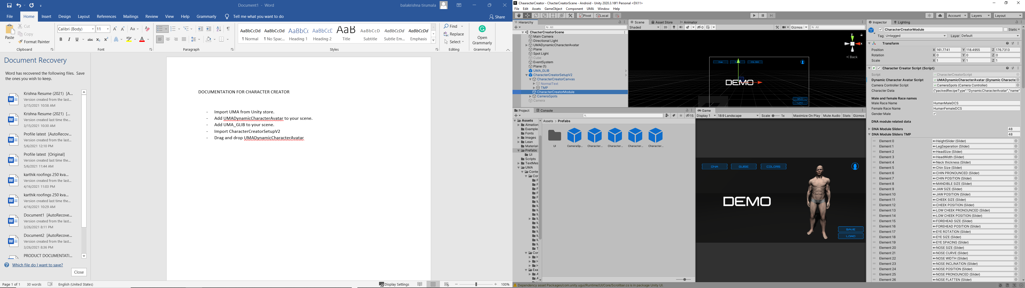

* Now go ahead and add the camera to the camera controller script attached to camera spots

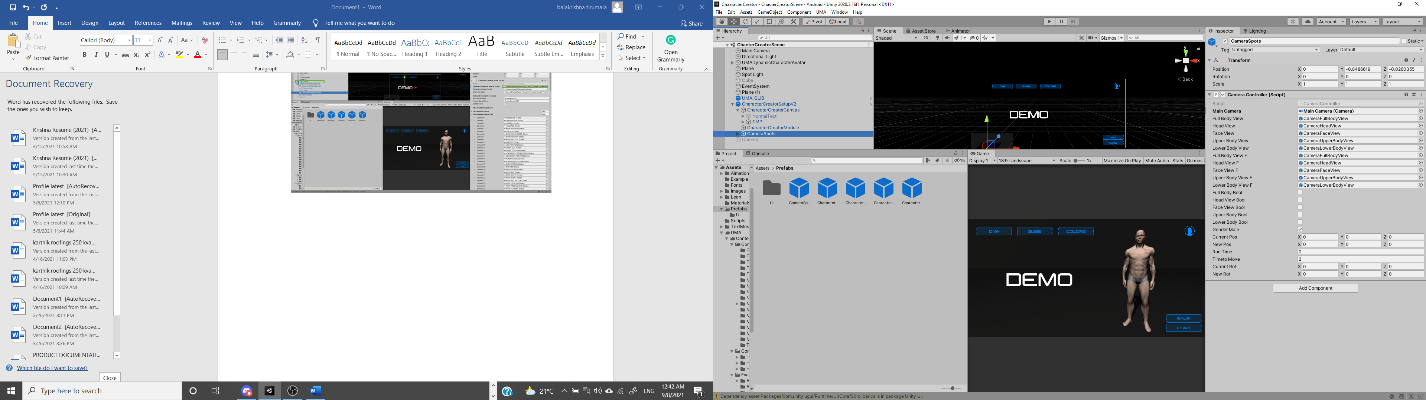

Setting camera angles

* Depending on the orientation and animations of the model you might want to change the camera angles.
* Please feel free to move the game objects inside Camera spots to adjust the positions for the camera in fullbodyview, faceView, headView, UpperBodyView and LowerBodyView accordingly.
* Also please note that there are two camera spots for male and female characters as they differ in default height. The script will automatically shift between them as on when characters change so please feel free to adjust the view if needed for female characters as well.

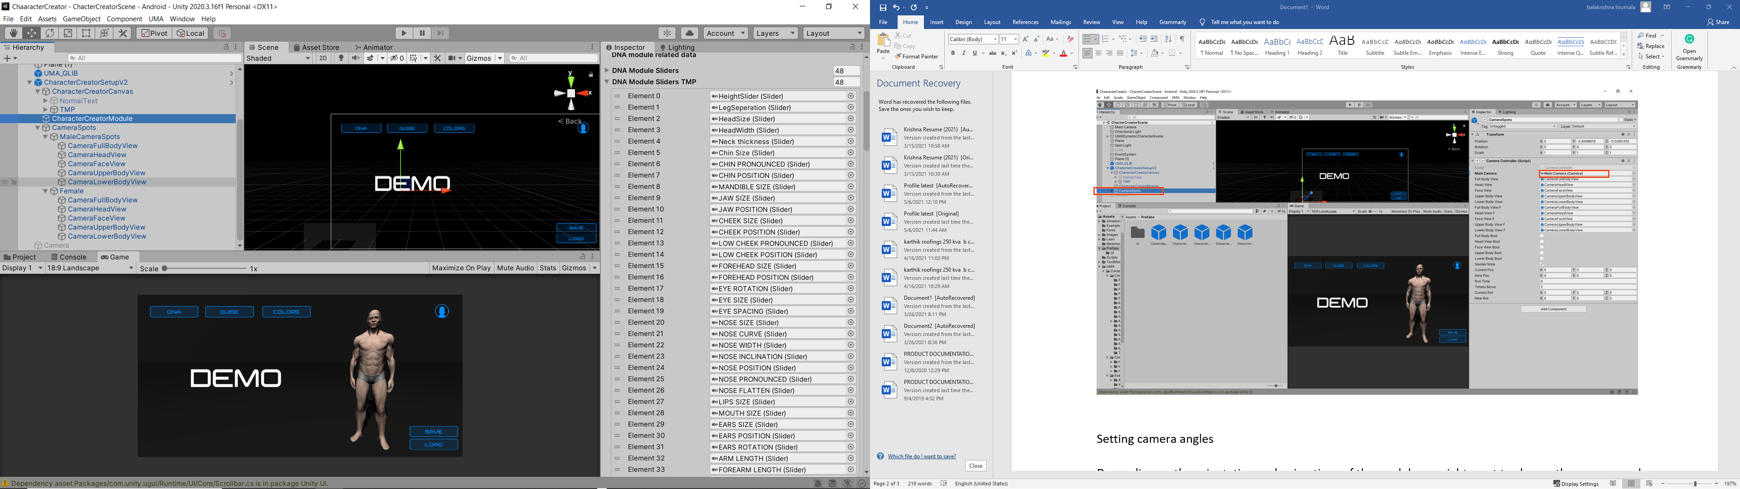

Adding DNA modules

* Almost all the DNA modules are covered for UMA_DCS. In case if you opt for custom race and need additional parameters to be added.
* Drag and drop a slider in the appropriate section of DNAModuleSliders. Increase the slider list by the number of new DNA parameters added and attach the slider to DNA Module Slider under DNA module related header in character creator script.

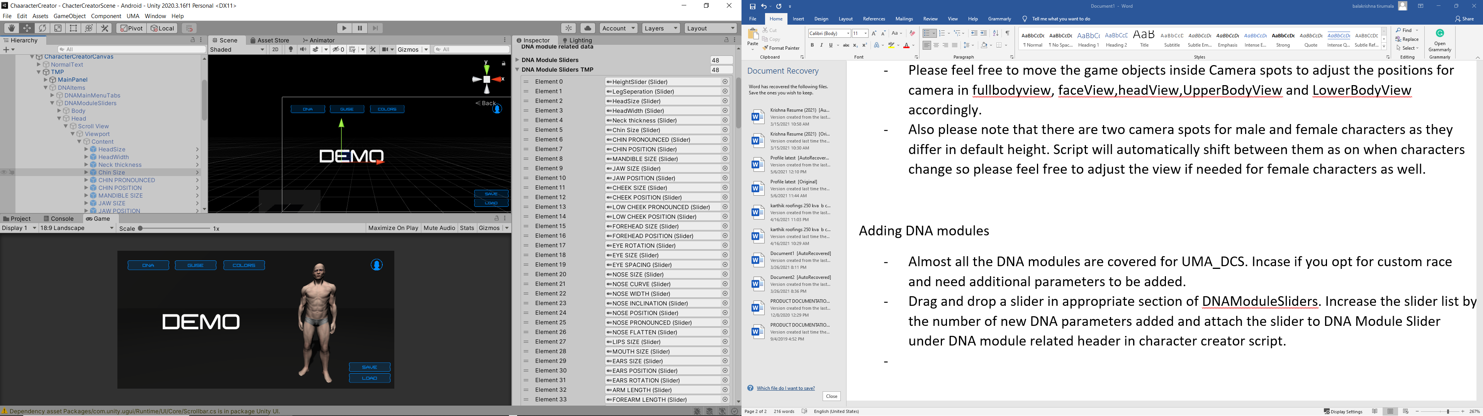

Switching between unity text and TMP

* This module has both TMP and also unity text implemented CharacterCreatorSetupV2 is currently set up to run using TMP in case if you would like to switch to unity text.
* Deactivate TMP game object inside charactercreatorcanvas and activate normalText game object.
* Also, uncomment line 167 and comment line 170 from CharacterCreatorScript.

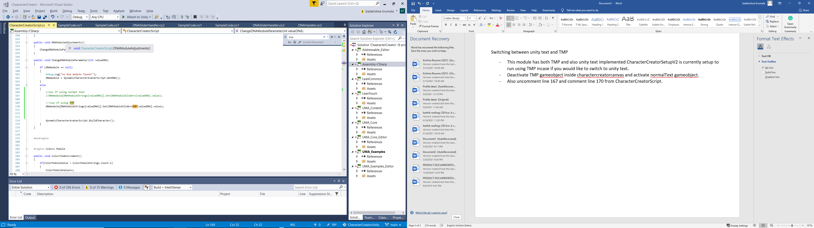

Adding new clothing and accessories

* This module currently has the recipes which are default with UMA from asset store. In future if you would like to add some custom recipes. Just add recipe name exactly to the respective slot available in the avatar by adding it to the respective list provided.

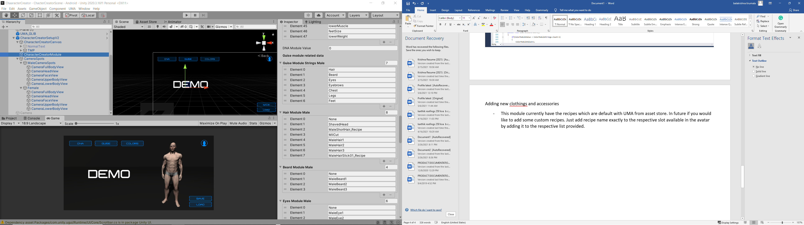

* In case you want to add new slot to the recipe. Add the string into respective guisemodulestrings list. And add the functions of that module in the code please browse as it is self-explanatory. Which can then be called into switch case as shown below.



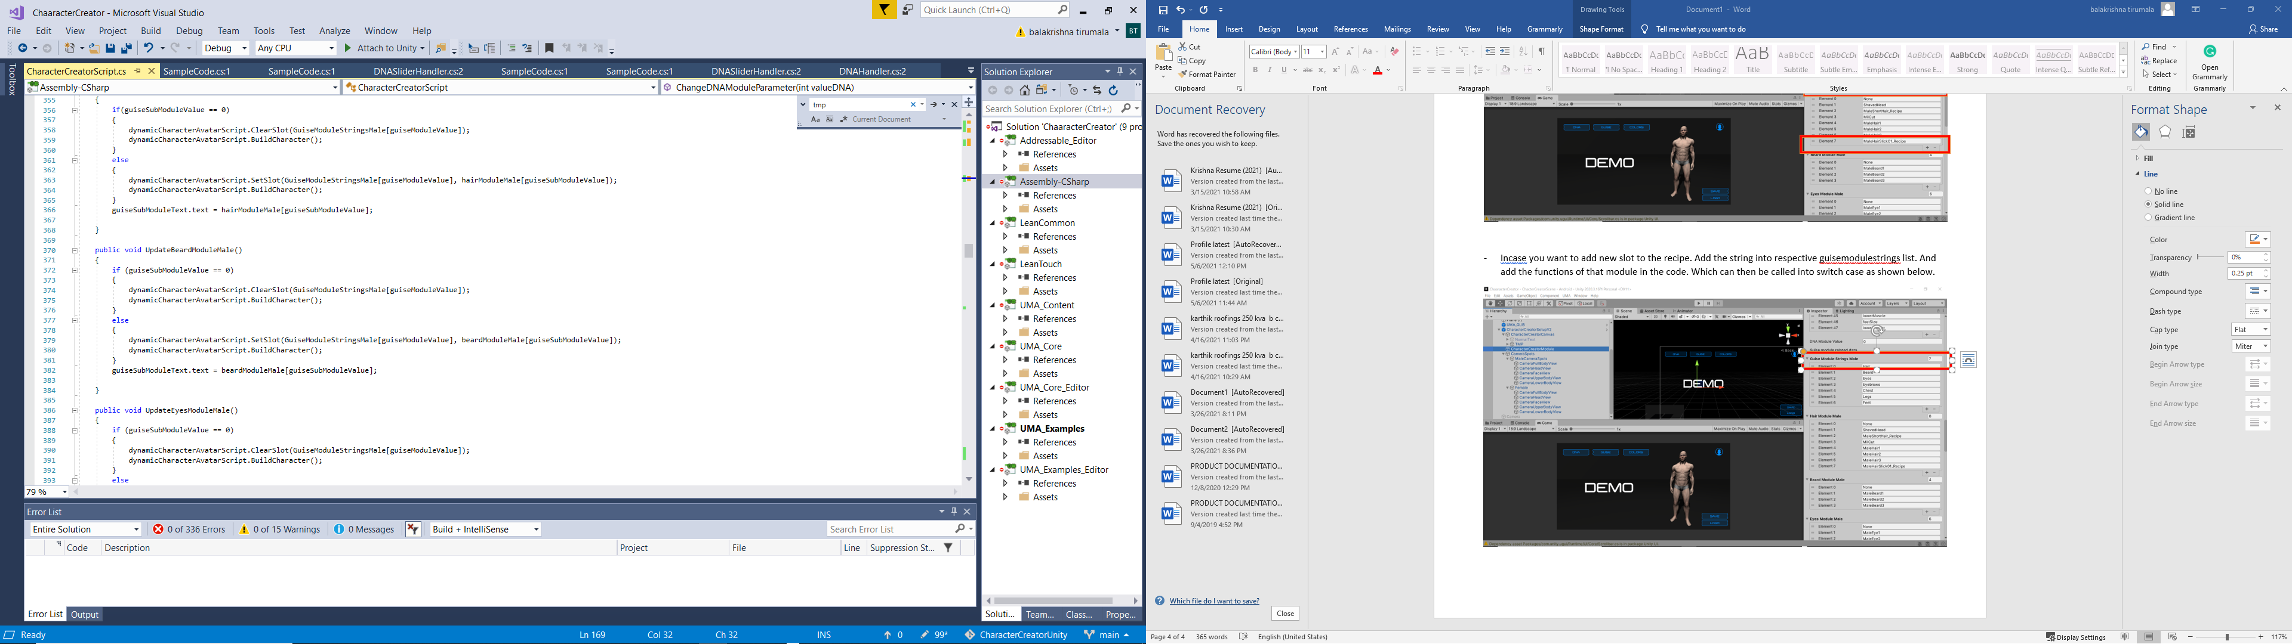

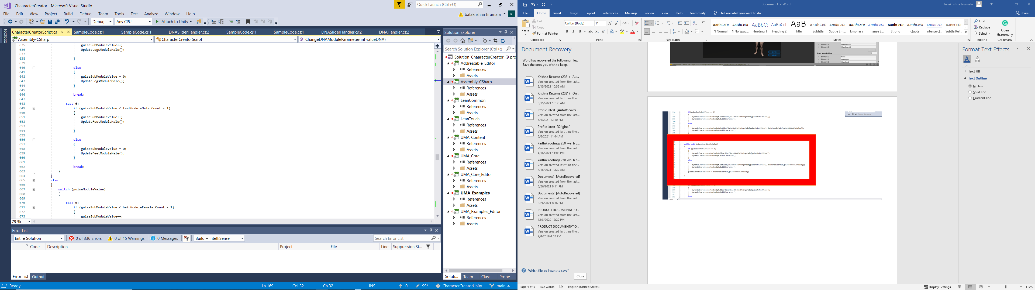

* Rest will be taken care of by the script and will appear in the UI in RUNTIME.

Saving and loading UMA:

* Use SaveCharacter() and LoadCharacter() function to save and load data to and from the string characterData in the CharacterCreatorScript.